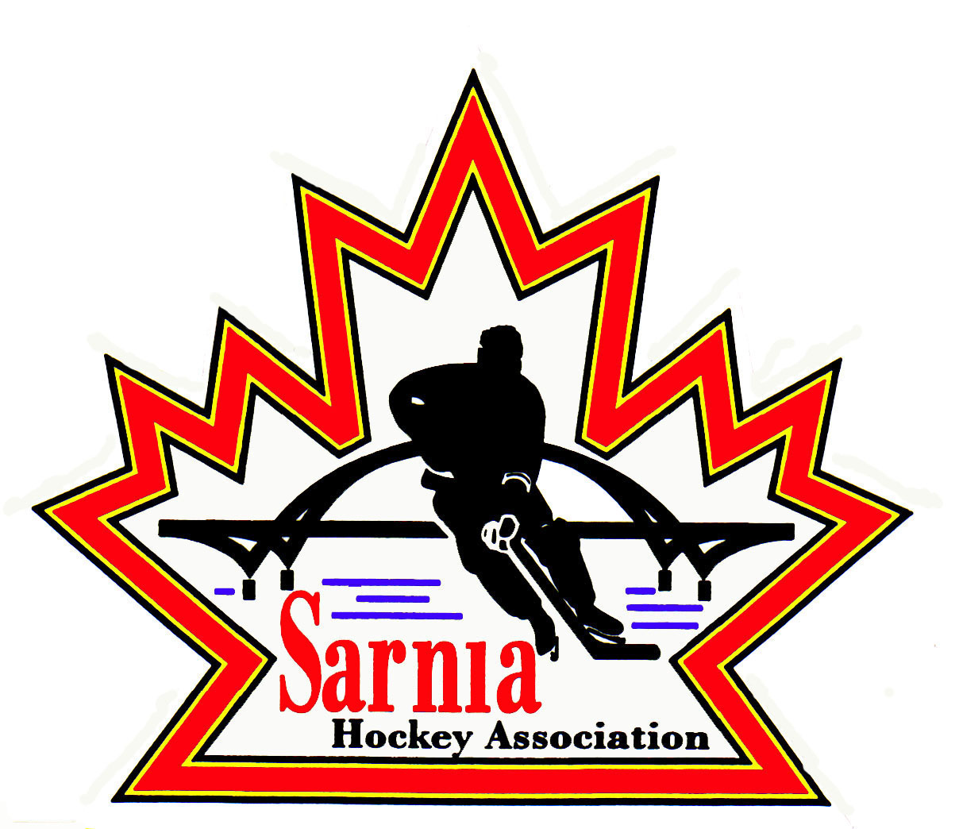

Sarnia Hockey Association

Minutes | Date: APRIL 23, 2025 | time 7:00 pm

Meeting called by | Paul Walsh, President
Type of meeting | Regular
Secretary | Barb Walsh, Acting Recording Secretary

Welcome | Paul Walsh, President, and meeting Chair welcomed everyone and called the meeting to order at 7:08 pm.

ATTENDANCE | Heather Amaral, Jacquie Beasley, Alister Brown, Emily Brown, Pat Forbes, , Don McGugan, John Mellor, David Penner, John Ritchie, Wayne Scarrow, Jason Teather, Barb Walsh, Paul Walsh  Regrets: Darren Chevalier, Bonny Marcy, Ted Pendle, Tim Turner, Jerry Bernardo, Chuck Ewart, Terry Gray, Dan Hunt, Kelly Lane, Linda Lauzon, Kyle Mellor, Blake Morrison

ACCEPTANCE OF MINUTES | MOTION #250423-001  “That the Minutes from March 19, 2025, be accepted as presented.” ( D McGugan/J. Mellor)  Carried

TREASURER’S REPORT | - Additional non-budgeted expense was incurred and needs formal approval by the board. The U15 A team won the ALLIANCE Championship, and this meant they would attend the U15 A OHF Finals in Collingwood on Easter Weekend. As this was an unexpected additional expense for the team, money was requested by the team to Sarnia Hockey and ALLIANCE. Sarnia Hockey and the ALLIANCE provide money for the team when a team goes to the OHF finals, but the amount Sarnia Hockey provides had not been set. It was discussed with Senior Executive and the amount of $200.00 per player was a reasonable amount and this is what was agreed upon. $3400.00 was transferred to the U15 A Team account. This will be added to 2025/26 budget.  - The team won a silver medal. Congratulations to them.  MOTION #250423-002  “That the U15A team be subsidized $3400.00 ($200.00 per player)” ( E. Brown/J Mellor)  Carried  Financial Report  - Ice bill is expected soon.  - U7 Festival and U8 Jamboree revenues look good, and the Winter Classic generated less than expected.  - Ice review is being done by Ice Scheduler to ensure split between Rep and Rec is accurate.  - Final numbers look to be in line, but it is hard to predict due to ice bill uncertainty.  MOTION #250423-003  “That the Financial Report be approved as presented.” ( E. Brown/A. Brown)  Carried

BILLS TO BE PAID | MOTION #250423-004  “That the bills be paid as presented.” ( E. Brown/Ritchie)  Carried
  Recipient | Expense | Amount
  April Bills:  Dante Club  Planet Stitch  Metcalfe Photography  Darren Rogers  Village of Point Edward  Alliance  Alister Brown  John Mellor  Dan Hunt  SHA Treasurer | Volunteer Appreciation Event  Rep Pucks  Goalie equipment (Cousi funded)  Rep and Rec photos  Prep Skate sessions  Ice bill  A/AA Championship Team fees  Officiating Fees  Travel Permits  Goalie Equipment  Half Ice Boards Repair  Volunteer Appreciation misc, items  U7 Festival volunteer meals  U8 Jamboree volunteer meals  Volunteer Award (13 x $100.00)  Rep Coach Incentives | $ 2,445.00  $ 1,921.00  $ 1,254.30  $ 10,938.97  $ 2,712.00  1,320.00  $ 5,800.00  $ 303.00  $ 340.00  $ 411.18  $ 127.64  $ 75.09  $ 160.49  $ 75.09  $ 450.00  $ 1300.00  $ 9000.00

REP DIRECTOR | - Congratulations to the U15 A team on their Silver Medal!  - Representative tryouts set to start on Saturday.  - Registration is ongoing due to Player Movement and registration for B tryouts to accommodate late registrations as players move on from AAA and A.  - Preliminary and updated lists provided to coaches. Each tryout is 1.5 hours, if split then 2 must be offered. Coaches will communicate process via team website.  - Al Brown, Dan Hunt and Jeff Fogal want to see and will support the ALLIANCE U7 Festival and U8 Jamboree hosted by Sarnia.  MOTION #250423-005  “That Sarnia Hockey apply to host the ALLIANCE U7 Festival and U8 Jamboree.” ( A. Brown/E. Brown)  Carried

ICE DIRECTOR | - Tryout ice is done  - Finalize bills for ice.  - Website turnover has been done.

REC EQUIPMENT DIRECTOR | VOLUNTEER APPRECIATION NIGHT:  - Volunteer Appreciation night was well attended and was enjoyed by all  CITY ARENAS FIRE SAFETY REVIEW:  - Review completed with user groups.  - PASA 2 lockers may need to be moved or shifted to ensure Accessible Seating is not obstructed.  - PASA 2 is undergoing updates.  - CWB is scheduled to get new boards.  - Pat Stapleton may need to be opened one week earlier to accommodate users if arena is not available.
Photography DIRECTOR | PHOTOS:  - Photos are ready, but some special items are not done.  - Will be available at Clearwater on Friday, Saturday and Sunday.
CLinics DIRECTOR | CLINICS:  - Scheduled for Sunday at Pat Stapleton Arena.  - Another clinic will be scheduled for September for those that require it before game play begins.  - A refresher will be held before December.  - Not enough need to run a D1 Clinic here, but we will provide locations to those requesting it.

NEW BUSINESS | 2025/26 BOARD POSITIONS UP FOR ELECTION:  - Communicate to W. Scarrow and P. Walsh your plans for the upcoming season.  - Need to discuss succession planning.  - Nominations close at 7Pm on May 6.  SHA AGM:  - May 6 is Sarnia Hockey AGM. This will be posted on SHA website.  BUDGETS:  - Submit to Budget Committee that consists of Treasurer, President, Vice President Administration.  - Budgets need to be submitted by April 30.  - Treasurer reminded those that are submitting budgets to factor in cost-of-living expenses and potential tariff impacts. Specify the contingency in your submission.  - Also consider 2% cost of living.  ALLIANCE AGM:  - Alliance AGM is scheduled for June 20-21 at Four Points Sheraton in London.  - Golf at Fire Rock on June 20 with dinner following at the hotel.  - June 21 is the AGM meeting from 8:30am to noon.  - If interested in attending, please contact Paul Walsh.  - We are allowed 10 delegates on a first come first serve basis.  - Registration deadline is May 31.  NEXT MEETING:  - Next meeting is the AGM on Tuesday, May 6, 2025 at Clearwater Lower Hall.

adjournment | MOTION #250423-006  “That the meeting be adjourned.” (Scarrow/J. Teather)  Carried

Paul Walsh Kelly Lane
President Secretary

